**ASSIGNMENT - 12.2**

**Problem Statement:**

Create a flume agent that streams data from Twitter and stores it in the HDFS cluster. You can refer the below link document steps to perform the above task :

<https://github.com/prateekATacadgild/Flume.git>

**Solution:**

* **Consumer Key & Consumer Secret Key**

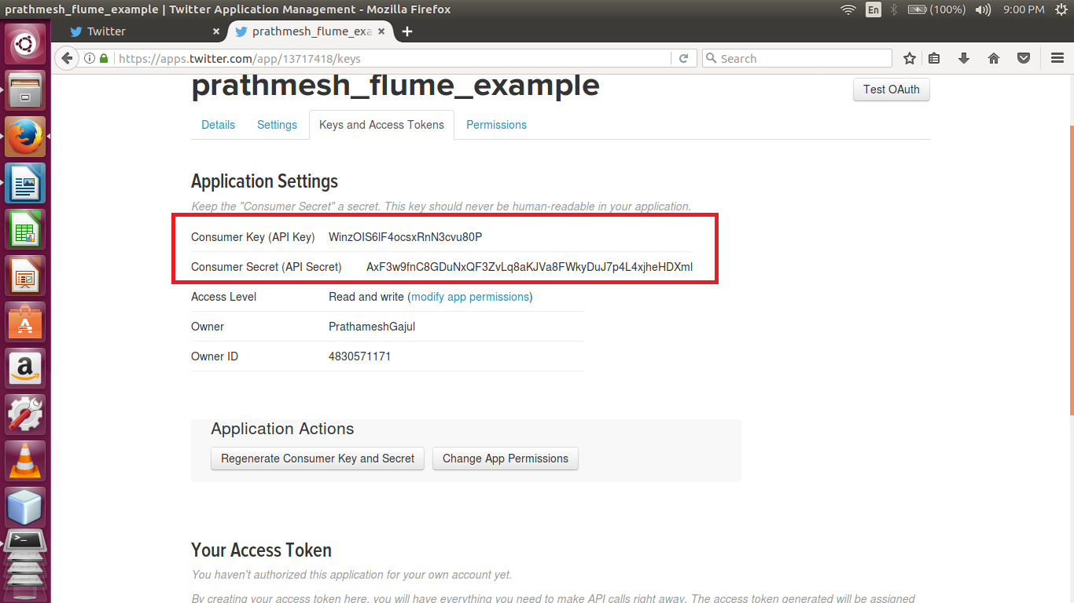

* **Access Token & Access Token Secret**

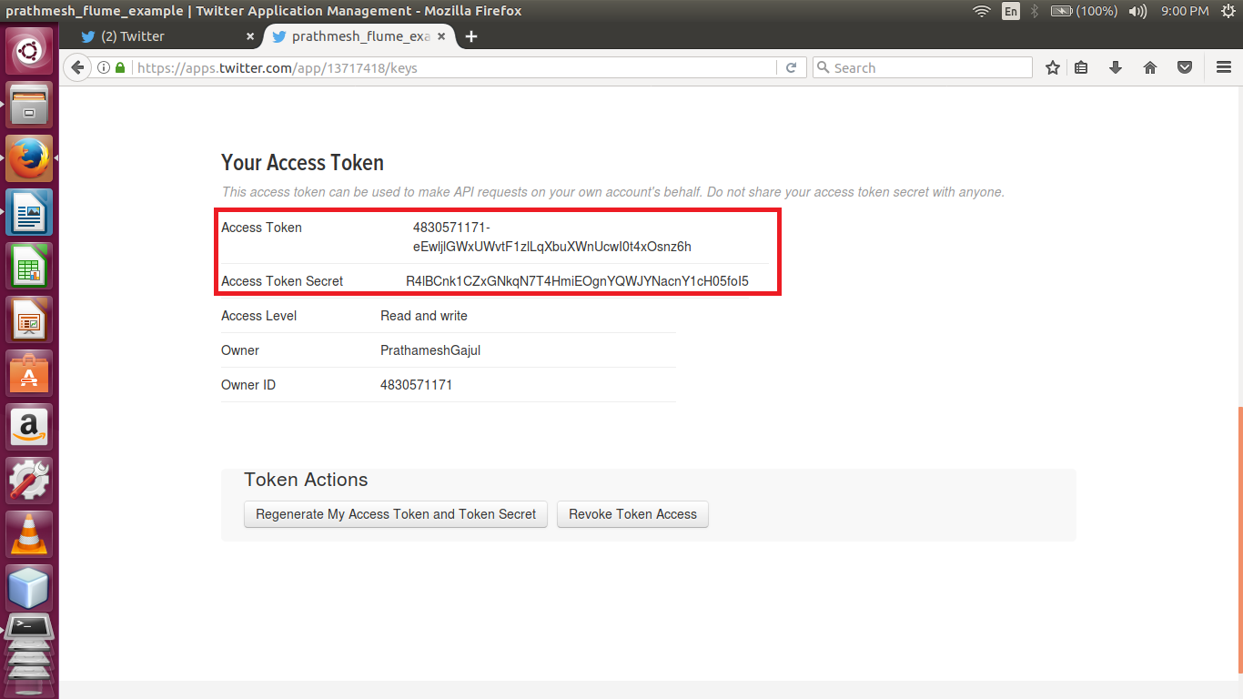

* **Flume Configuration file**

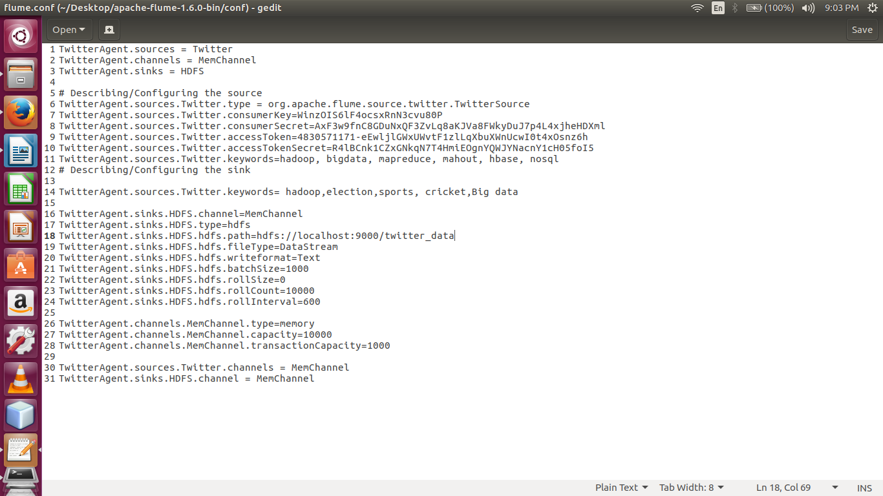

* **Stream Twitter data using flume –ng command**

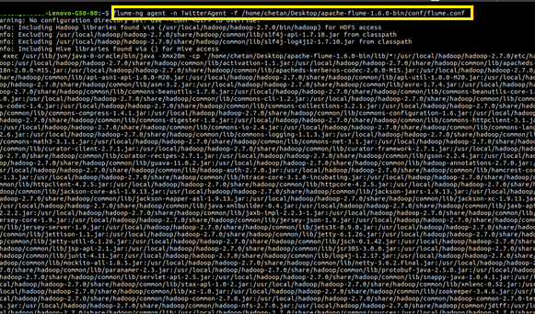

* **Display the contents of the directory twitter_data**

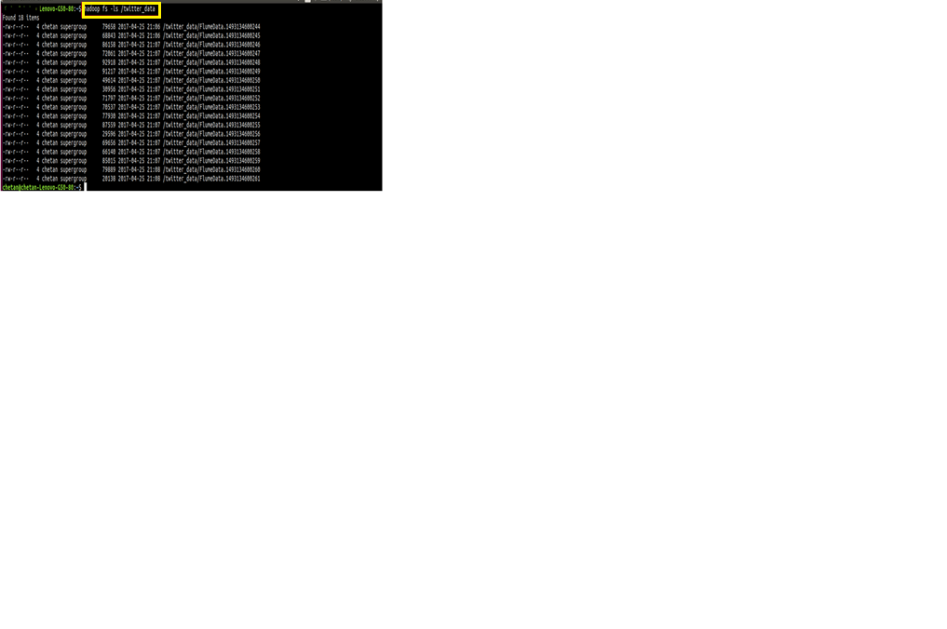

* **Display the contents of the file**

